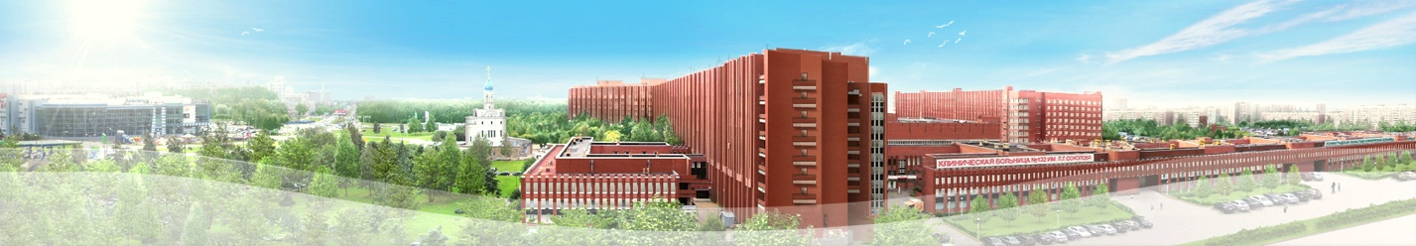
III INTERNATIONAL CONFERENCE
«SCHOOL OF THE GASTRIC SURGERY»

April 28
8:00-9:00. Registration, coffee-break.

9:00-9:15. Opening of the conference.

Welcome by president of the hospital № 122 professor J. NAKATIS
Welcome by chief surgeon of St-Petersburg professor P.YABLONSKIY

9:15-9:30. The presentation of the patients
9:30-14:00. Live surgery by Russian surgeons as a followers of Japanese surgical school.
Laparoscopic gastrectomy with D2 lymph node dissection
Thoraco-laparoscopic esophagectomy
Laparoscopic gastric bypass
EUS for staging of gastric cancer
ESD for gastric lesion
14:00-14:30. Coffee-break.
Symposium: "Current issues of pathology in gastric cancer"
14:30-15:00. T. Shimoda Macroscopic findings of early gastric cancer related with microscopic features.
15:00-15:15. Discussion
15:15-15:45. S. L. Vorobyov Barrett's Esophagus: terminology, morphological monitoring.
15:45-16:00. Discussion
16:00-16:30. K. V. Shelekhova Morphological diagnosis of fibroid polyps of the stomach.
16:45-17:15. T. ShimodaBiopsy diagnosis of gastric cancer and endosopicfeartures.
17:15-17:30. Discussion
17:30-18:00. Case conference of gastric cancer with pathologist,endoscopist and surgeon
T. Shimoda , S. L. Vorobyov, R. V. Orlova

April 29
Morning lecture
8:30-9:00 – Coffee break.
9:00-10:00. I. UyamaMinimally invasive gastrectomy: our experience and future perspectives.
Symposium: "D2 lymph node dissection"
10:00-10:30. Key note lecture 1: M. Nakauchi, K. Suda, I. Uyama Totally laparoscopic gastrectomy: tips and tricks for D2 dissection.

10:30-11:00. A. M.KarachunThe technique of the lymph node dissection during laparoscopic gastrectomy.
11:00-11:15.V.Kashchenko,K.SudaDifferent approaches to the suprapancreatic D2-lymph node dissection.

11:15-11:45. R. V.OrlovaLymphadenectomy in the neoadjuvantera.

11:45-12:15. T. ShimodaThe prognostic significance of isolated tumor cells in the lymph nodes of gastric cancer patients
12:15-12:30.Discussion.
12:30-13:00 Lunch
Symposium «Laparoscopic reconstruction after gastrectomy»
13:00-13:30. Key note lecture 2: M. Nakauchi, K. Suda, I. Uyama Totally laparoscopic gastrectomy: tips and tricks for intracorporeal anastomosis.
13:30-14:00. A. M. Karachun Technique for reconstructive phase during laparoscopic gastrectomy.

14:00-14:30. V. Kashchenko,K.SudaThe reconstruction after gastrectomy according to the Japanese recommendations

14:30-14:45Discussion.

14:45-15:00 Coffee-break
Symposium: Diagnosis and treatment of the non-epithelial esophageal and gastric tumors
15:00-16:00. T. ShimodaHistological diagnosis of neuroendocrine tumor.
16:00-16:30. E. G. Solonitsyn, O.B. TkachenkoDiagnosis non-epithelial esophageal and gastric tumors in the endosonographyera.
16:30-17:00. V.G. PishchikThoracoscopic approach for non-epithelial esophageal tumors (clinical cases)
17:00-17:30. A. M. Karachun, Y.V.Pelipas Laparoscopic procedures for GIST: selection, operative technique.
17:30-18:00. R. V. Orlova, Multimodal approach forGIST
18:00. Closing of the conference.

